**Class Assignment#3:**

**Question1:**

**Code:**

/*  
Name: Abdullah Mehdi   
Regstration No: SP21-BCS-OO2  
Class Assignment: multiplying 2 matrices   
*/  
import java.util.*;  
import java.lang.*;  
public class ClassQ1{  
 public static void main(String[] args){  
 Scanner input = new Scanner(System.in);  
  
 System.out.println("Enter number of rows of 1st matrix");  
 int row1 = input.nextInt();  
 System.out.println("Enter number of columns of 1st matrix");  
 int col1 = input.nextInt();  
 System.out.println("Enter number of rows of 2nd matrix");  
 int row2 = input.nextInt();  
 System.out.println("Enter number of columns of 2nd matrix");  
 int col2 = input.nextInt();  
  
 int[][] mulMatrix = new int[row1][col2];   
 int[][] matrix = new int[row1][col1];  
 int[][] matrix2 = new int[row2][col2];  
  
 int empty = 0;  
  
 if(col1 == row2){  
 // inserting elements of 1st matrix  
 System.out.println("Enter the elements of 1st matrix");  
 for(int row = 0; row < matrix.length; row++){  
 for(int col = 0; col < matrix[row].length; col++){  
 int user = input.nextInt();  
 matrix[row][col] = user;   
 }  
   
 }  
  
 // inserting elements of 2nd matrix  
 System.out.println("Enter the elements of 2nd matrix");  
 for(int row = 0; row < matrix2.length; row++){  
 for(int col = 0; col < matrix2[row].length; col++){  
 int user = input.nextInt();  
 matrix2[row][col] = user;   
 }   
 }  
 System.out.println("---------------------------");  
 System.out.println("The first matrix is:");  
 printMatrix(matrix);  
 System.out.println("The second matrix is:");  
 printMatrix(matrix2);  
 // multiplying two matrices  
 System.out.println("The multiplied matrix is");  
 for(int row = 0; row < row1; row++){  
 for(int col = 0; col < col2; col++){  
 for(int detector = 0; detector < col1; detector++){  
 mulMatrix[row][col] += matrix[row][detector] * matrix2[detector][col];  
 }   
 }   
 }   
 }  
 else{  
 System.out.println("Matrix multiplication is not possible!");  
 }  
  
 printMatrix(mulMatrix);  
  
 }  
  
  
 public static void printMatrix(int[][] array){  
   
 // printing sum-ed matrix  
 for(int row = 0; row < array.length; row++){  
 for(int col = 0; col < array[row].length; col++){  
 System.out.print(array[row][col] + " ");  
 }  
 System.out.println();  
 }  
 System.out.println();  
 }  
}

**Output:**

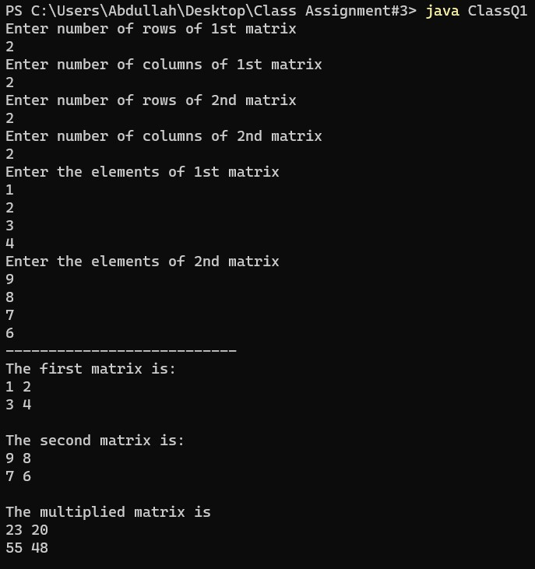

**Question2:**

**Code:**

/*  
Name: Abdullah Mehdi   
Regstration No: SP21-BCS-OO2  
Class Assignment: arranging a b and c   
*/  
import java.util.*;  
import java.lang.*;  
public class ClassQ2{  
 public static void main(String[] args){  
 Scanner input = new Scanner(System.in);  
 System.out.println("Enter a, b or c: (input ends with 0)");  
 String string = "";  
 int size = 0;  
 while(true){  
 String character = input.next();  
 if(character.equals("0")){  
 break;  
 }  
 else{  
 string += character ;   
 size++;   
 }  
   
 }  
 // inserting string elements in an array  
 char[] array = new char[size];  
 char temp = 'a';  
 for(int i = 0; i < size; i++){  
 array[i] = string.charAt(i);  
 }  
 for(int i = 0; i < array.length; i++){   
 for(int j = i+1; j < array.length; j++){   
 if(array[i] > array[j]) {   
 temp = array[i];   
 array[i] = array[j];   
 array[j] = temp;   
 }   
 }   
 }   
  
 // sorting characters in an Array   
 System.out.println("--------- The result is ---------");  
 for(int i = 0; i<array.length; i++){  
 System.out.print(array[i]);   
 }  
  
  
 }  
}

**Output:**

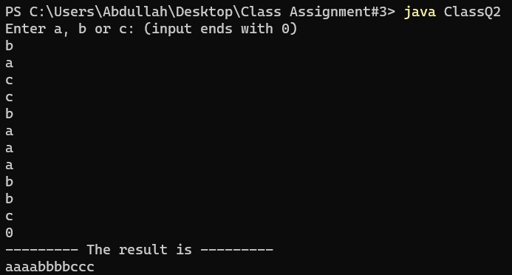

**Question3:**

**Code:**

/*  
Name: Abdullah Mehdi   
Regstration No: SP21-BCS-OO2  
Class Assignment: menu driven java program  
*/  
import java.util.*;  
import java.lang.*;  
public class ClassQ3{  
 public static void main(String[] args){  
 Scanner input = new Scanner(System.in);  
  
 System.out.println("Enter the length of the array! ");  
 int user = input.nextInt();  
 int[] array = new int[user];  
  
 System.out.println("Enter the array elements! ");  
 for(int i = 0; i < array.length; i++){  
 int user1 = input.nextInt();  
 array[i] = user1;  
 }  
  
 while(true){  
 System.out.println("\n------------ Menu ------------");  
 System.out.println("Your array is:");  
 printArray(array);  
 System.out.println("\n--------------------------------");  
 System.out.println("Press 1 to counts the occurrences of a number");  
 System.out.println("Press 2 to adjust the position of a number X");  
 System.out.println("Press 3 to calculate the frequencies of all the numbers");   
 System.out.println("Press 4 to replace a number by sum of next two numbers");  
 System.out.println("Press 5 to shift an array by 2 numbers");  
 System.out.println("Press 6 to Exit");  
   
 int user2 = input.nextInt();  
 if(user2 == 1){  
 System.out.println();  
 count(array);   
 }  
 else if(user2 == 2){  
 System.out.println();  
 partition(array);   
 }  
 else if(user2 == 3){  
 System.out.println();  
 duplicates(array);   
 }  
 else if(user2 == 4){  
 System.out.println();  
 circular(array);   
 }  
 else if(user2 == 5){  
 System.out.println();  
 shiftCircular(array);   
 }  
 else if(user2 == 6){  
 break;   
 }  
  
 }  
 }  
 public static void printArray(int[] list){  
 for(int i = 0; i < list.length; i++){  
 System.out.print(list[i] + " ");  
 }   
 }  
 public static void count(int[] count){  
 Scanner input = new Scanner(System.in);  
 System.out.println("Enter the number to find its occurence! ");  
 int user = input.nextInt();  
 int occurence = 0;  
 for(int i = 0; i < count.length; i++){  
 if(count[i] == user){  
 occurence++;  
 }  
 }  
 System.out.println(user + " occures " + occurence + " times ");  
  
 }  
 public static void partition(int[] count){  
 int x = count[0];  
 int temp = 0;  
 for(int i = 0; i < count.length; i++){   
 for(int j = i+1; j < count.length; j++){   
 if(count[i] > count[j]) {   
 temp = count[i];   
 count[i] = count[j];   
 count[j] = temp;   
 }   
 }   
 }  
 System.out.println("The partioned array is: ");  
 for(int i = 0; i < count.length; i++){  
 System.out.print(count[i]);  
 }  
 System.out.println();  
  
  
 }  
 public static void duplicates(int[] count){  
 System.out.println("-------------------------\nElements are: ");  
 for(int i = 0; i < count.length; i++){  
 System.out.print(count[i] + " ");   
 }  
 System.out.println("\n-------------------------\nOccurences are: ");   
 int[] newArray = new int[count.length];  
 int check = -1;   
 int occurence = 0;   
 for(int i = 0; i < count.length; i++){   
 occurence = 1;  
 for(int j = i+1; j < count.length; j++){   
 if(count[i] == count[j]){   
 occurence++;   
 newArray[j] = check;   
 }   
 }   
 if(newArray[i] != check)   
 newArray[i] = occurence;   
 }  
 for(int i = 0; i < newArray.length; i++){   
 if(newArray[i] != check)   
 System.out.println(count[i] + " has occured " + newArray[i] + " time/s");   
 }   
  
 }  
 public static void circular(int[] count){  
 int[] newArray = new int[count.length];  
 for(int i = 0; i != count.length; i++){   
 for(int j = i+1; j < count.length; j++){   
 newArray[j] = (count[i] + count[j]);   
 }   
 }  
 System.out.println("The sum-ed array is: ");  
 for(int i = 1; i < newArray.length; i++){  
 System.out.print(newArray[i]);  
 }  
 System.out.println();  
 }  
 public static void shiftCircular(int[] count){  
 int[] newArray = new int[count.length];  
 int[] newArray2 = new int[2];  
 for(int i = 0; i != count.length; i++){   
 for(int j = i+2; j < count.length; j++){   
 newArray[j] = count[j];  
 }   
 }  
 for(int j = 0 ; j < 2; j++){  
 newArray2[j] = count[j];  
 }  
 int[] finalArray = new int[(count.length) + 2];  
 System.out.println("The shiffted array is 2: ");  
 System.arraycopy(newArray, 0, finalArray, 0, count.length);   
 System.arraycopy(newArray2, 0, finalArray, count.length, newArray2.length);   
 for(int j = 2 ; j < finalArray.length; j++){  
 System.out.print(finalArray[j]);  
 }  
 System.out.println();  
  
  
  
 }  
}

**Output:**

